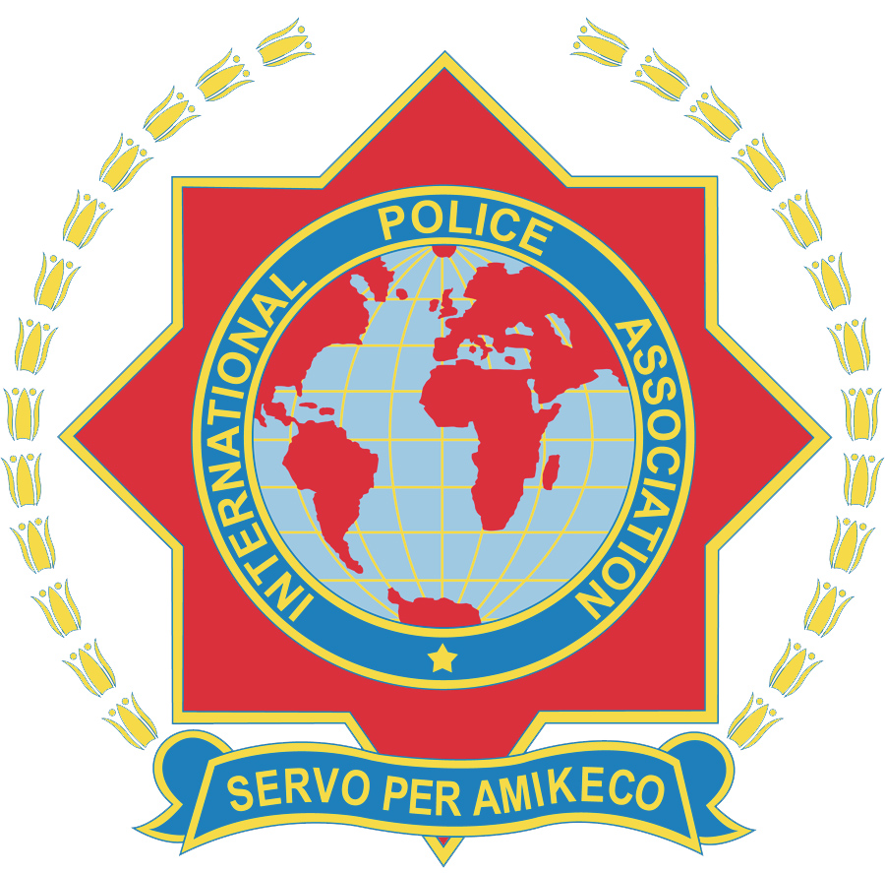
INTERNATIONAL POLICE ASSOCIATION SECTION MONTENEGRO
Bul Svetog Petra Cetinjskog 22, 81000 Podgorica, Montenegro
Web: www.ipamontenegro.me E-mail: secretary@ipamontenegro.me

IPA MONTENEGRO FRIENDSHIP WEEKS 2016
The Montenegro Tour - 18th to 25th May 2016 REGISTRATION FORM
PLEASE IN BLOCK CAPITAL LETTERS Registration Deadline: 1st April 2016
Family Name: |  | First name: |  |  | Male/Female:
Address:
Postal code: |  |  | Country:
Date of Birth: |  |  | Languages:
IPA Section: | IPA Number: |  |  | Number of accompanying person/s:  (must complete separate registration form)
Passport/National ID Number: |  | Date of issue: |  |  | Expiry Date:
E-mail: |  |  | Phone:
ACCOMMODATION
Single room: |  | Double room: |  |  | Twin room:
Special requirements:
TRAVEL INFORMATION
Date and time of arrival: |  |  | Date and time of Departure:
Flight Number: |  |  | Flight number:
Other means of transportation:
COSTS AND BOOKING CONDITIONS
PROGRAMME
Double/Twin: €550 per person sharing. Single: €690 |  |  | Deposit €200 per person due on registration
Balance of payment by 2nd May 2016 |  |  | Deposit nonrefundable after 2nd May 2016
TRAVEL AGENCY AND BANK ACCOUNT INFORMATION
IPA Montenegro Friendship Weeks 2016 Atlas Banka AD Podgorica
DOO EXPLORER IBAN: ME25505120000000265186
Mojkovačka bb,81210 Kolašin, Montenegro SWIFT(BIC): ATLMMEP2
Mojkovačka bb, 81210 Kolašin, Montenegro

Mojkovacka bb Kolasin 81210 Montnegro
Signed: |  |  | Date:
Booking forms/Enquiries it is necesssary to be sent on-line to email address: travel@ipamontenegro.me
Contact telephone: +382 69 033 164
