INTERNATIONAL POLICE ASSOCIATION
NATIONAL SECTION OF LITHUANIA
_______________________________________________________________________
To Presidents of Latvia, Estonia and Poland Sections and Associate members IPA in Georgia |  |  |  |  | 20-03-2017 No 17-2 (17)
THE MOST NOTABBLE, THE GREATEST AND THE MOST EXCITING ANNIVERSARY IPA GATHERING
”THE SPIRIT OF SPORT IN OUR HEARTS“
30 June – 2 July
In Trakai Wellness and Recreation Park “SLĖNIS“(Valley)

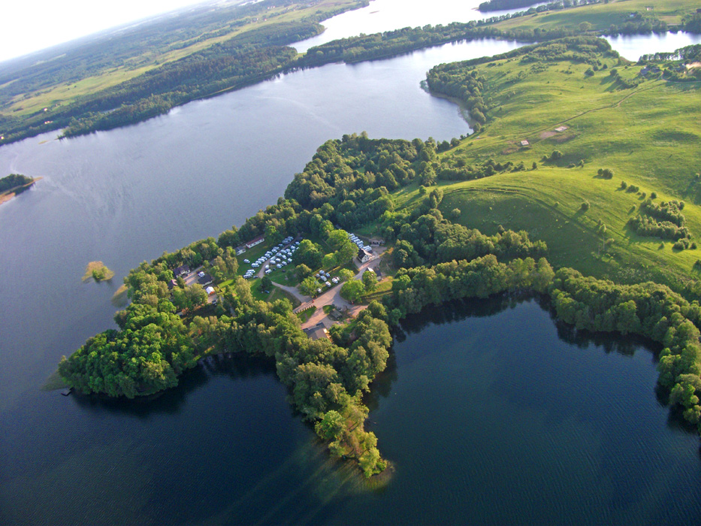

A special anniversary gathering of the IPA National Section of Lithuania – the 20-ieth gathering – will be held this year!
Thank you for being together!
This weekend full of the spirit of sport in Trakai Wellness and Recreation Park “SLĖNIS“(Valley) is an excellent opportunity to meet old friends and to find new ones as well as to make new acquaintances while admiring the magnificent surroundings of Trakai and spending your time pleasantly, vivaciously and healthy. We invite the members of all branches of the IPA Lithuania, IPA foreign national sections of various ages together with their families united and interrelated by common activities, ideas and hobbies to this wonderful feast. Branches participating in the gathering will have a possibility to celebrate the achievements of their members in sports, dance, talent and lots of other areas. Well, and we will make our best to integrate everything, what you have the best in specially selected activities and forms, into the overall programme of the gathering. We have prepared lots of prizes and surprises to the participants of the gathering. And the most importantly that a great mood, positive emotions, unexpected discoveries and unforgettable experiences are waiting for you the whole weekend!
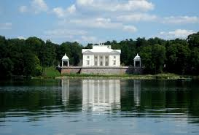 | We will send the programme of the event later.  The gathering will be held in the Wellness and Recreation Park “SLĖNIS“ (Valley) (Slėnio Str. 1, Trakai, 54’6686106, 24’9296334). Participants will be provided with a possibility to pitch their tents within the territory of the gathering or with a possibility to get accommodation in the 22 rooms of the camping houses (1 double room (46 Euro) , 7 triple rooms (52 Euro), 11 four-bedded rooms (70 Euro), 1 five-bedded (86 Euro), 2 six-bedded rooms (104 Euro)*.

Whereas the number of houses is limited, the priority will be given to those members/branches, who were the first to register and perform a payment transfer. Furthermore, it is possible to book rooms in Trakai hotels located near the place of the gathering: www.trasalis.lt, www.priegalves.lt, www.prieezero.lt
In the territory, there are stationary toilets and showers as well as bio-toilets will also be provided. We recommend organising the arrival at destination by buses, whereas the parking for private transport vehicles will be available only in some distance from the camping site (approximately 1-2 km).
The organisers shall not be liable for the safety of things left on the campsite or outside the territory thereof.
Could you please notify us before 9 June 2017 about the following: whether your team is going to participate in the gathering, how many participants will be including children under 12 years of age, where are you going to book your accommodation. Your applications (please find an application form enclosed hereto) should be sent to Vilnius Branch to the following e-mail addresses: rolandas.sepetys@policija.lt and diana.stukiene@vsat.vrm.lt | 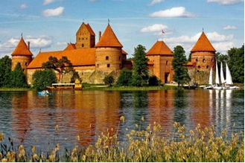
Please transfer a participant’s fee – 10 Euro for each person (children under 12 years of age shall b exempted from the fee) not later than until 16 June 2017 to the bank account of the IPA Vilnius Branch C/a LT49 7044 0600 0795 2440 (AB SEB Bank, bank code 70440), specifying “For the gathering” as the purpose of payment and the name of your branch.

Organizers:

Rolandas Šepetys
Mob.: +370 687 45133
E-mail: rolandas.sepetys@policija.lt

Diana Stukienė
Mob.: +370 614 87306
E-mail: diana.stukiene@vsat.vrm.lt

With best regards

IPA LS President Vytautas Pliuskus

*The price is indicated for the whole period of the gathering.

