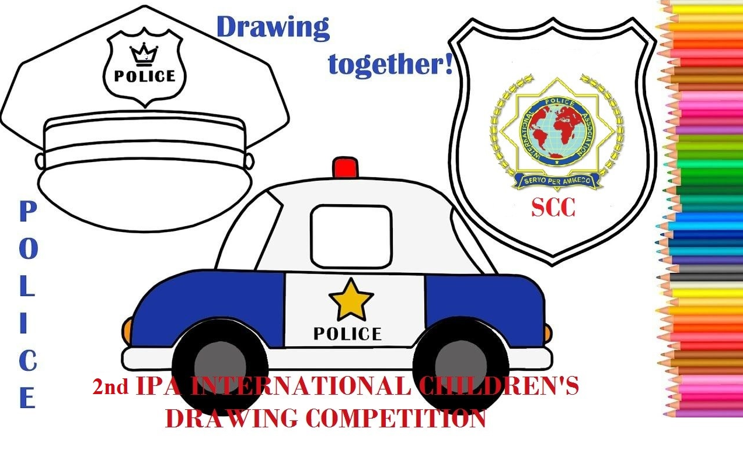 | INTERNATIONAL POLICE ASSOCIATION  INTERNATIONAL EXECUTIVE BOARD  SOCIO-CULTURAL COMMISSION  2nd IPA INTERNATIONAL CHILDREN’S  DRAWING COMPETITION
ENTRY FORM
Member’s name:
Member’s IPA card no:
Relation with the child:
Child’s name:
Child’s date of birth:
Section:
Topics of the painting:  (Mark with X) | Police at work  Police and animals  Children of the world

GUARDIAN’S CONTACT DETAILS
Address:
Mobile tel. number:
Email:

As the signer below, I hereby declare that the above information is true and by posting
this entry, I confirm that I have read and accepted the terms of the competition.

Date:
Place:
Signature:

ENTRIES THAT WILL BE RECEIVED LATER THAN 30-9-2021 WILL BE REJECTED

