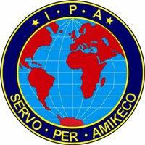
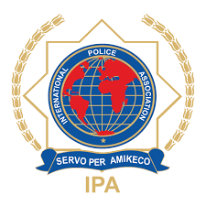

МЕЃУНАРОДНО ПОЛИЦИСКО ЗДРУЖЕНИЕ – ОДДЕЛ МАКЕДОНИЈА
INTERNATIONAL POLICE ASSOCIATION – SECTION NORTH MACEDONIA
ИПА Регион СКОПЈЕ – IPA Region SKOPJE
www.IPA.MK & ipa-skopje.mk

IPA BALKAN-ADRIATIC CONFERENCE
12-14 November 2021 ,Skopje, North Macedonia
Hotel Double Tree by Hilton – Skopje

REGISTRATION FORM (2)

NAME____________________________________ Surname ________________________________

ADDRESS ___________________________________________ email_________________________

NATIONAL SECTION/Region________________________________________________________

Acompanied by:_____________________________________________________________________

Arrival: by plane (airport) ________________________ (need transfer from airport) YES/ NO

Date_________________ Time_____________________ Flight no.___________________________

Departure: by plane (airport) ________________________ (need transfer to airport) YES/ NO

Date_________________ Time_____________________ Flightno.___________________________

Contact (phone)______________________________________________________________________

ACCOMMONDATION REQUIRED: Double room / Single room

NOTES:

- Accommodation is in Hotel Double Tree by Hilton in double rooms,If visitors are participating the cost per participant is 200 euros per person sharing a double room if any of the participants wants to use a single room there is an extra charge of 75 euros per night.
- The price includes the accommondations, transportations, excursions and meals.Paument will be done on arrival
- The registration form to be sent no later than November 1, 2021

SIGNATURE_________________________ DATE___________________

